Practical 1

Using ‘R’ execute the basic array,list and frames

List:A list is an R-object which can contain many different types of elements inside it like vectors,function and even another list inside it.

> list1=list(c(2,6.5,sin))

> print(list1)

[[1]]

[[1]][[1]]

[1] 2

[[1]][[2]]

[1] 6.5

[[1]][[3]]

function (x) .Primitive("sin")

> print(class(list1) )

[1] "list"

Array:While matrices are confined to two dimensions,array can be of any number of dimensions.The array function takes a dim attribute which creates the required number of dimension.

> a=array(c("yes","no"),dim=c(3,3,2))

> print(a)

, , 1

[,1] [,2] [,3]

[1,] "yes" "no" "yes"

[2,] "no" "yes" "no"

[3,] "yes" "no" "yes"

, , 2

[,1] [,2] [,3]

[1,] "no" "yes" "no"

[2,] "yes" "no" "yes"

[3,] "no" "yes" "no"

Frames:Data frames are tabular data objects.Unlike a matrix in data frame each column can contain different modes of data.The first column can be numeric while the second column can be character and third column can be logical.It is list of vectors of equal length.Data frames are created using the data.frame() function.

> BMI=data.frame(gender=c("Female","Female","Male","Female"),

+ height=c(152,155,165.2,170),

+ weight=c(35,40,60,55),

+ age=c(14,16,20,17))

> print(BMI)

Gender Height Weight Age

1 Female 152.0 35 14

2 Female 155.0 40 16

3 Male 165.2 60 20

4 Female 170.0 55 17

Practical 2

Create a matrix using R and perform the operation addition ,inverse ,transpose and multiplication operations.

> A<-matrix(c(2,3,-2,1,2,2),3,2)

> print(A)

[,1] [,2]

[1,] 2 1

[2,] 3 2

[3,] -2 2

> B<-matrix(c(1,4,-2,1,2,1),3,2)

> print(B)

[,1] [,2]

[1,] 1 1

[2,] 4 2

[3,] -2 1

> C=A+B

> print(C)

[,1] [,2]

[1,] 3 2

[2,] 7 4

[3,] -4 3

> E<-matrix(c(2,1,6,1,3,4,6,4,-2),3,3)

> print(E)

[,1] [,2] [,3]

[1,] 2 1 6

[2,] 1 3 4

[3,] 6 4 -2

> AI<-solve(E)

> print(AI)

[,1] [,2] [,3]

[1,] 0.2156863 -0.25490196 0.13725490

[2,] -0.2549020 0.39215686 0.01960784

[3,] 0.1372549 0.01960784 -0.04901961

> AT<-(A)

> print(AT)

[,1] [,2]

[1,] 2 1

[2,] 3 2

[3,] -2 2

> ATT<-t(AT)

> print(ATT)

[,1] [,2] [,3]

[1,] 2 3 -2

[2,] 1 2 2

> D<-A\*B

> print(D)

[,1] [,2]

[1,] 2 1

[2,] 12 4

[3,] 4 2

Practical 3

Using R execute the statistical functions mean ,median ,mode ,quartile ,range ,Inter-quartile range ,histogram.

1.Mean

> x<-c(12,7,3,4,2,18,2,54,-21,8,-5)

> mean<-mean(x)

> print(mean)

[1] 7.636364

2.Median

> x<-c(12,7,3,4,2,18,2,54,-21,8,-5)

> median<-median(x)

> print(median)

[1] 4

3.Mode

> getmode<-function(v){

+ uniqv<-unique(v)

+ uniqv[which.max(tabulate(match(v,uniqv)))]

+ }

> v<-c(2,1,2,3,1,2,3,4,1,5,5,3,2,3)

> result<-getmode(v)

> print(result)

[1] 2

4.Quartile

> nuclear<-c(7,20,16,6,58,9,20,50,23,33,8,10,15,16,104)

> quantile(nuclear)

0% 25% 50% 75% 100%

6.0 9.5 16.0 28.0 104.0

5.Range and histogram

> x<-c(1,2,3,2,3,4,8,12,43,-4,-1)

> r<-range(x)

> print(r)

[1] -4 43

> diff(r)

[1] 47

> hist(r)

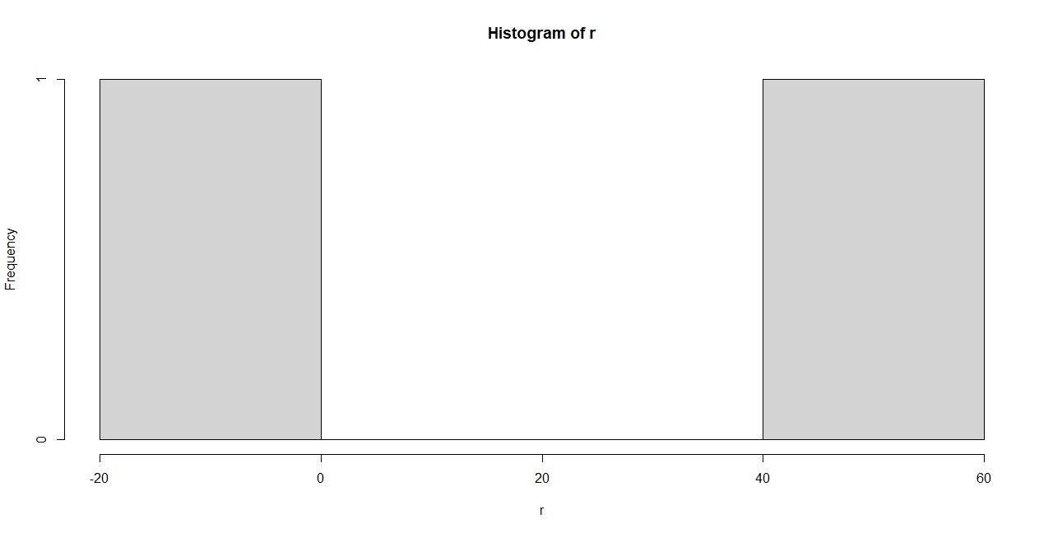

6.Inter Quartile Range

> x<-c(12,19,21,24,26,29,33,35,36)

> IQR(x)

[1] 12

Practical 4

Using R import the data from excel/.CSC file and perform the above function.

> data1<-read.csv(file.choose(),header=T)

> data1

No. x

1 2 12

2 2 7

3 3 3

4 4 4

5 5 2

6 6 18

7 7 2

8 8 54

9 9 -21

10 10 8

11 11 -5

> mean(data1$x)

[1] 7.636364

> median(data1$x)

[1] 4

Practical 5

Using R import the data from excel/.CSC file and calculate the standard deviation,variance and covariance.

1.Standard deviation

> data2<-read.csv(file.choose(),header=T)

> data2

x

1 2

2 3

3 7

4 8

5 10

> sd(data2$x)

[1] 3.391165

2.Variance

> data2<-read.csv(file.choose(),header=T)

> data2

x

1 1

2 2

3 3

4 4

5 5

6 6

7 7

8 8

9 9

> var(data2$x)

[1] 7.5

Practical 6

Using R import the data from Excel/.csv and draw the skewness and kurotsis.

Seema is interested on the elapse time (in minutes).She spends on riding a tricycle from home to school for three weeks(excluding weekends).She obtain the following data:

19.55,17.69,17.63,25.15,27.27,25.24,21.65,20.92,22.61,15.71,22.04,22.60,24.25

Compute and interpret the skewness and kurtosis

> time<-c(19.55,17.69,17.63,25.15,27.27,25.24,21.65,20.92,22.61,15.71,22.04,22.60,24.25)

> library(moments)

> skewness(time)

[1] -0.1958679

> kurtosis(time)

[1] 2.168551

Practical 7

1.Suppose the manufacturer claims that the mean lifetime of a light bulb is more than 10,000 hours.In a sample of 30 light bulbs ,if we was found that they only last 9,000 hours on average.Assume the population standard deviation is 120 hours.At .05 significance level,can we reject the claim by the manufacturer?

> xbar=9900

> mu0=10000

> sigma=120

> n=30

> z=(xbar-mu0)/(sigma/sqrt(n))

> z

[1] -4.564355

> alpha =.05

> t.alpha=qt(1-alpha,df=n-1)

> t.alpha

[1] 1.699127

2.Suppose the food label on a cookie bag states that there is atmost 2 grams of saturated fat in single cookie.In a sample of 35 cookie,it is found that the population standard deviation is 0.25 grams.At 0.05 significance level,can we reject the claim on the food label?

> xbar<-2.1

> mu0<-2

> sigma<-0.25

> m<-35

> z=(xbar-mu0)/(sigma/sqrt(n))

> z

[1] 2.19089

> z.alphs<-qnorm(1-alpha)

> alpha<-0.05

> z.alpha

> z.alpha

[1] 1.644854

Practical 8

Import the data from Excel/.CSV file and perform the chi squared test

> local({pkg <- select.list(sort(.packages(all.available = TRUE)),graphics=TRUE)

+ if(nchar(pkg)) library(pkg, character.only=TRUE)})

> library("MASS")

> print(str(Cars93))

'data.frame': 93 obs. of 27 variables:

$ Manufacturer : Factor w/ 32 levels "Acura","Audi",..: 1 1 2 2 3 4 4 4 4 5 ...

$ Model : Factor w/ 93 levels "100","190E","240",..: 49 56 9 1 6 24 54 74 73 35 ...

$ Type : Factor w/ 6 levels "Compact","Large",..: 4 3 1 3 3 3 2 2 3 2 ...

$ Min.Price : num 12.9 29.2 25.9 30.8 23.7 14.2 19.9 22.6 26.3 33 ...

$ Price : num 15.9 33.9 29.1 37.7 30 15.7 20.8 23.7 26.3 34.7 ...

$ Max.Price : num 18.8 38.7 32.3 44.6 36.2 17.3 21.7 24.9 26.3 36.3 ...

$ MPG.city : int 25 18 20 19 22 22 19 16 19 16 ...

$ MPG.highway : int 31 25 26 26 30 31 28 25 27 25 ...

$ AirBags : Factor w/ 3 levels "Driver & Passenger",..: 3 1 2 1 2 2 2 2 2 2 ...

$ DriveTrain : Factor w/ 3 levels "4WD","Front",..: 2 2 2 2 3 2 2 3 2 2 ...

$ Cylinders : Factor w/ 6 levels "3","4","5","6",..: 2 4 4 4 2 2 4 4 4 5 ...

$ EngineSize : num 1.8 3.2 2.8 2.8 3.5 2.2 3.8 5.7 3.8 4.9 ...

$ Horsepower : int 140 200 172 172 208 110 170 180 170 200 ...

$ RPM : int 6300 5500 5500 5500 5700 5200 4800 4000 4800 4100 ...

$ Rev.per.mile : int 2890 2335 2280 2535 2545 2565 1570 1320 1690 1510 ...

$ Man.trans.avail : Factor w/ 2 levels "No","Yes": 2 2 2 2 2 1 1 1 1 1 ...

$ Fuel.tank.capacity: num 13.2 18 16.9 21.1 21.1 16.4 18 23 18.8 18 ...

$ Passengers : int 5 5 5 6 4 6 6 6 5 6 ...

$ Length : int 177 195 180 193 186 189 200 216 198 206 ...

$ Wheelbase : int 102 115 102 106 109 105 111 116 108 114 ...

$ Width : int 68 71 67 70 69 69 74 78 73 73 ...

$ Turn.circle : int 37 38 37 37 39 41 42 45 41 43 ...

$ Rear.seat.room : num 26.5 30 28 31 27 28 30.5 30.5 26.5 35 ...

$ Luggage.room : int 11 15 14 17 13 16 17 21 14 18 ...

$ Weight : int 2705 3560 3375 3405 3640 2880 3470 4105 3495 3620 ...

$ Origin : Factor w/ 2 levels "USA","non-USA": 2 2 2 2 2 1 1 1 1 1 ...

$ Make : Factor w/ 93 levels "Acura Integra",..: 1 2 4 3 5 6 7 9 8 10 ...

NULL

> car.data<-data.frame(Cars93AirBags,Cars93$Type)

> car.data<-data.frame(Cars93$AirBags,Cars93$Type)

> car.data=table(Cars93$AirBags,Cars93$Type)

> print(car.data)

Compact Large Midsize Small Sporty Van

Driver & Passenger 2 4 7 0 3 0

Driver only 9 7 11 5 8 3

None 5 0 4 16 3 6

> print(chisq.test(car.data))

Pearson's Chi-squared test

data: car.data

X-squared = 33.001, df = 10, p-value = 0.0002723

Q.Suppose there are 12 multiple types question in an English class quiz each question has 5 possible answers,and only one of them is correct.Find the probability of having 4 or less correct answers if a student attempt to every question at random.

> dbinom(4,size=12,prob=0.2)

[1] 0.1328756

> dbinom(0,size=12,prob=0.2)+

+ dbinom(1,size=12,prob=0.2)+

+ dbinom(2,size=12,prob=0.2)+

+ dbinom(3,size=12,prob=0.2)+

+ dbinom(4,size=12,prob=0.2)

[1] 0.9274445

> pbinom(4,size=12,prob=0.2)

[1] 0.9274445

Normal distribution:

Assume that the test scores of a college entrance exam fits a normal distribution.Furthermore,the mean test score is 72 and the S.D. is 15.2.What is the percentage of students scoring 84 or more in the exam?

Soln :We apply the function pnorm of the normal distribution with the mean 72 and S.D. 15.2.Since we are looking for the percentage of students scoring higher than 84.

Practical 9

Using R perform the binomial and normal distribution on the data.

> x<-seq(0,50,by=1)

> y<-dbinom(x,50,0.5)

> png(file="dbinom.png")

> dev.off()

null device

1

> plot(x,y)

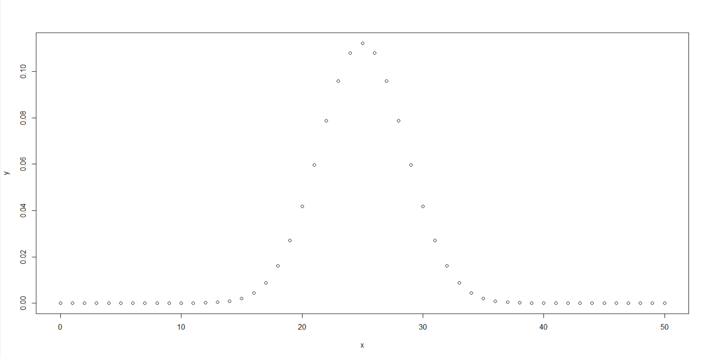

Practical 10

Perform the Linear Regression using R.

> x<-c(151,174,138,186,128,136,179,163,152,131)

> y<-c(63,81,56,91,47,57,76,72,62,48)

> relation<lm(y~x)

> png(file="linearregression.png")

> dev.off()

null device

1

> plot(y,x,col="blue",main="Height & Weight Regression",

+ abline(lm(x~y)),cex=1.3,pch=16,xlab="Weight in Kg",ylab="Height in cm")

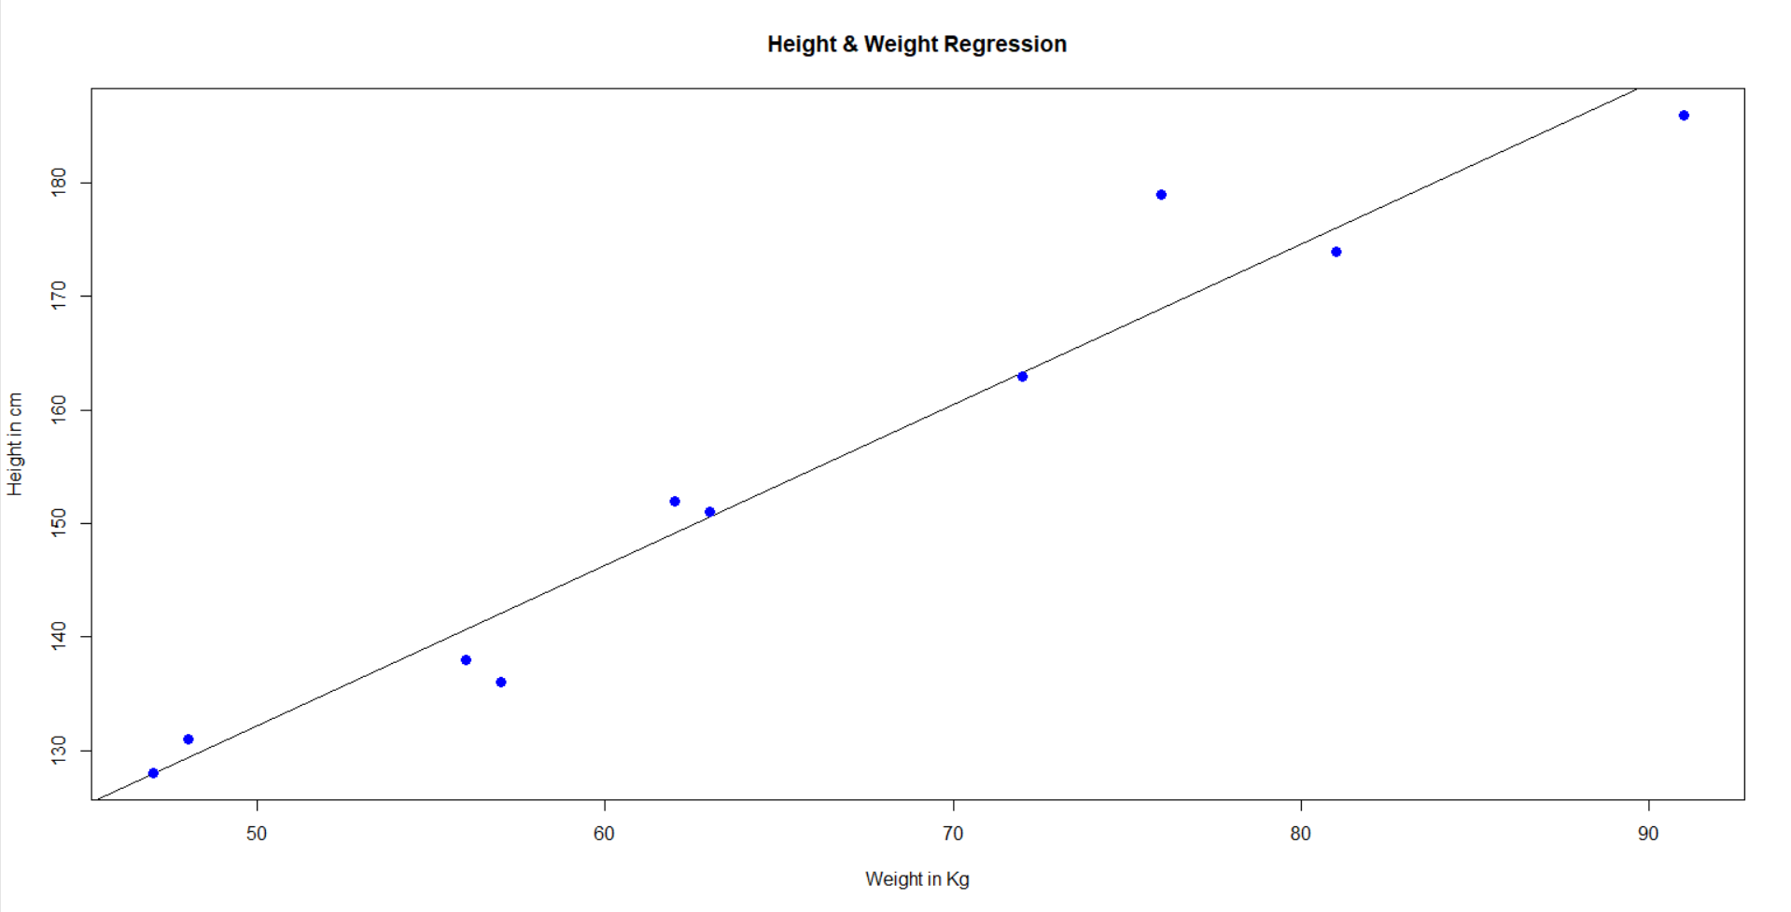

Practical 11

Perform the correlation using R tool.

> year<-c(2000,2001,2002,2003,2004)

> rate=c(9.34,8.50,7.62,6.93,6.60)

> plot(year,rate)

> cor(year,rate)

[1] -0.9880813

